|  |
| --- |
| BLUEsat UNSW Student Satellite Project  Document BLUE.2011.1.1 |
| BLUEsat Primer |
| An introduction to the BLUEsat Student Satellite Project |
| **Authors and Contributors:**  Thien Nguyen – Chief Technical Officer 2011  Mitch Wenke  **Date:** |
| 9/30/2011 |

# Introduction

After a history of poor documentation management, this document is the first effort to try to formalise the way in which records are kept within the BLUEsat project. The aim of this and the ongoing documentation overhaul is ensure the project matures professionally and the integrity of BLUEsat’s engineering practices is maintained.

The purpose of this report is to consolidate the design of BLUEsat into a single document. The intention is that, by reading this particular report, the reader will be able to gain an overview of the nature of the BLUEsat project, its mission, project management philosophy and a brief technical overview of the design of the satellite itself.

Whilst this report contains some amount of technical detail regarding the design of the satellite, it is not intended to be a fully detailed technical master file. The rationale and overall design of each sub-system will be described such that the reader understands the nature of the satellite itself and how each system is related to each other.

Documents are currently being worked on that contain greater technical detail regarding the design of the satellite. However, with the drawing database and project wiki, knowledge of the design of the satellite is well maintained. If information further than the technical drawings is required, for now, the reader should consult the members of the project directly.

# Table of Contents

1 Introduction 1

2 Table of Contents 2

3 Table of Figures 2

4 Project Background 4

4.1 Project Inception 4

4.2 Current Generation 5

4.3 Alumni 5

5 Project Management and SCRUM 7

5.1 Team Roles 7

5.2 Sprint Reviews 8

6 Satellite Technical Overview 9

6.1 Specifications 9

6.2 System Design 10

6.3 Mechanical Structure 12

6.4 Communications 15

6.5 Critical Systems Computer 19

6.6 Power Overview 23

6.7 Solar Array 24

6.8 Battery Charge Regulator 26

6.9 Voltage Regulation 28

6.10 Telemetry 30

6.11 Payloads 32

7 Progress Summary 33

# Table of Figures

Figure 5.1 - Illustration of Project Strucuture 7

Figure 6.1 – Satellite Systems Overview 10

Figure 6.2 - Exploded view of the satellite tray system 13

Figure 6.3 - Communications Layout 16

Figure 6.4 - Switching Circuit Signal Flow 17

Figure 6.5: CSC OS Structure 20

Figure 6.6 - Simplified overview of the Satellite Power System 23

Figure 6.7 - Exploded view of Satellite structure including solar Array 24

Figure 6.8 - Battery Pack Assembly 26

Figure 6.9 - Telemetry System Overview 30

# Project Background



## Project Inception

BLUEsat (Basic LEO UNSW Experimental Satellite) is a team comprised of circa thirty undergraduate students from the University of New South Wales. The BLUEsat Project aims to design, build and launch an amateur radio microsatellite with room to grow and experiment with new designs in the future. We are heavily interdisciplinary and draw talent from a wide variety of schools within the university in order to form a team with a complete skillset. The current team structure, though larger than past generations is still recruiting as the team gains momentum.

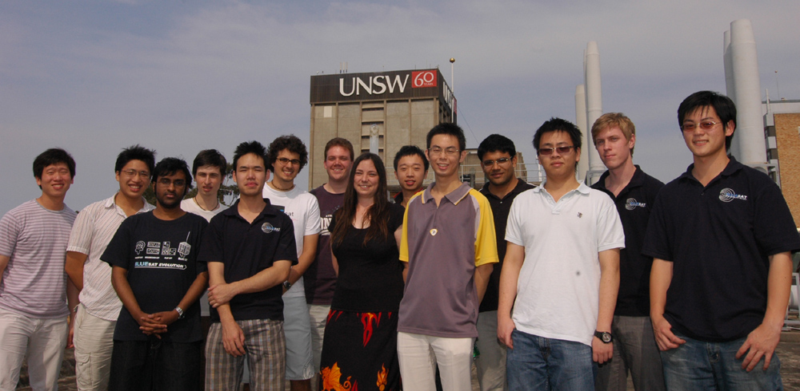

BLUEsat’s inception traces back to the creation of the UNSW chapter of National Space Society of Australia (NSSA.) Called the UNSW Space Frontier Society, it was founded in 1997 by a group of undergraduate students. Looking for a focus, in 1998 the group turned their attention to the *Y-Prize*, an Australian spoof of the X Prize Foundation which would award $500 to the first Australian amateur group to launch a nano communications satellite. Coined BLUEsat, after half a year of research the group received their first grant of $10,000 from the UNSW U-Committee.

In 1999, the group implemented a formal project management structure and was offered their current ground station, an unused RF shielded room which was being occupied as the University Club's wine cellar. With help from the UNSW School of Electrical Engineering, the room was refurbished for BLUEsat’s use.

In the following years, BLUEsat had many achievements and faced many challenges. Elements of the satellite were the focus of dozens of UNSW undergraduate student’s theses. The project also received a number of notable grants and sponsorships from. However, BLUEsat faced membership challenges, as the project struggled to recruit new students. The satellite underwent a number of redesigns, triggered by the generational nature of BLUEsat’s member base. In 2004, a poster campaign to recruit new members generated an overwhelming response of over 50 students, creating a new enthusiasm within the project.

In 2005, design begun on the current generation of BLUEsat. Mechanical Engineering Student Chris Hales completed his thesis on the design and manufacturing of the current satellite’s structure, and BLUEsat was privileged with a productive team which laid many of the design foundations the project relies on today.

This period produced some of BLUEsat’s most successful alumni. However with no one to replace them when they graduated, the project suffered from a loss of momentum.

## Current Generation

In 2007 through 2008, BLUEsat again struggled with poor membership and low productivity. This loss of productivity was the result of a lack of foresight in Project Management philosophy. Whilst the original project model succeeded for a given number of people, it did not put in place infrastructure to cope with member loss due to graduation.

In light of BLUEsat’s past difficulties, in 2009 new, enthusiastic, members examined BLUEsat’s operation procedures and put in place amendments which have resulted in a healthy growth of the projects member base to date. Infrastructure was put in place to organise the group in a formal, yet supporting manner in order to realize the original idea from 1998.

The inception of this change in project management involved two major paradigm shifts.

The first major paradigm shift involves the effort undertaken to the management of BLUEsat’s human resources. The amount of workload involved in this undertaking was acknowledged and hence team management has instituted major recruitment drives and promotion of the project to both prospective students and current students in the university. A key result of this is the elimination of the generational phenomenon that was present in past teams. The team is now comprised of students ranging from first years students to final thesis students, with almost every member having enough knowledge and background to carry the project on.

The second paradigm shift involves the implementation of professional project management. AGILE and SCRUM, a software engineering managerial platform, are specifically attributable for our teams success in the past two years. We will be detailing the benefits of this system in more depth in 5 Project Management and SCRUM.

We have now accomplished a public release as a result, displaying a proof of concept of many of our Critical Systems represents a major step ahead for the project.

## Alumni

BLUEsat members have, once graduated, gone on to very successful careers in their chosen professions. The wide variety of skills and interests in highlighted in this regard.

* Daniel Faber, instrumental in the initial stages of the project is now on the Board of Advisors at the National Space Society and the President and CTO at Heliocentric Technologies incorporated.
* Anthony Wicht, who has worked on BLUEsat’s operations and solar teams, has since begun a graduate degree with the Massachusetts Institute of Technology.
* Chris Hales, a former President of the organisation and whose thesis on the BLUEsat structure graduated with First Class Honours and has since moved on to completing a PhD in Astronomy with the University of Sydney.
* Kate Cussen, who completed a thesis on vibrational testing of the BLUEsat structure, has since moved on to a career as a Spacecraft Analyst with Optus.
* Darran Siu is currently working as a Telecommunications Engineer at Ericsson Australia
* Chris Walsh, a former Chief Technical Officer now has a career with Honeywell.
* Colin Tan, a former Chief Operations Officer is now a software developer for Integrated Research.

# Project Management and SCRUM

BLUEsat exists as a collection of student volunteers working towards a common goal of continuous and productive development on the satellite. To achieve this we have implemented the Scrum framework of development.

The development satellite itself at any one time is broken into sub-projects. This allows the project to group logically relevant development goals into projects. Each of these subjects have self-contained problem statements that are attacked by a team of 4-7 BLUEsat members. This structure is illustrated below in Figure 5.1.

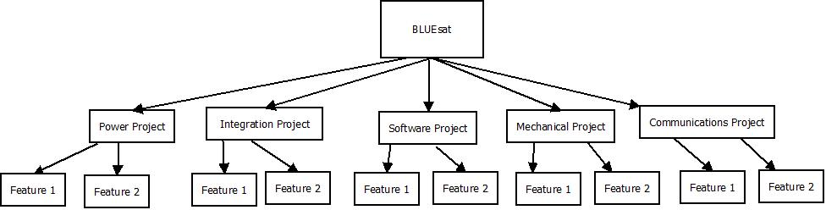

Figure 5.1 - Illustration of Project Structure

Using the Scrum framework we break then break down the sub-projects down into incremental, iterative goals. These goals are grouped together into time based development called sprints. Typically during the university semester a sprint occurs over three weeks.

Records are kept of project progress and timelines via a central project management database. This database is maintained by specific team members (see 5.1.2 Scrum Masters) through the use of the IceScrum project management tool.

The decision made to structure teams and members in the project in this way was made based upon the nature of member involvement in BLUEsat. A large or abrupt changes in available resources (volunteer developers becoming tied down with other commitments or graduating from the project) can be compensated for by a re-evaluation of project definitions and team distributions.

Maintaining a strict documentation database and record of project progress allows for this project redefinition to happen with relative ease. Emphasis is placed upon modularity, visibility of progress made and accessibility of information attained. Members are able to integrate into new projects with a strong ability to continue progress that was made, rather than having to redo old work.



## Team Roles

The hierarchy of BLUEsat members is used to establish a chain of responsibility. That said, it should be noted that BLUEsat maintains a strong ‘flat’ organisational structure, in that the opinions and concerns of all members (regardless of role or seniority) are handled with equal concern and weight.

The chain of responsibility and communication shown below in Figure 5.2 allows for issues to be followed up and for greater visibility in the project.

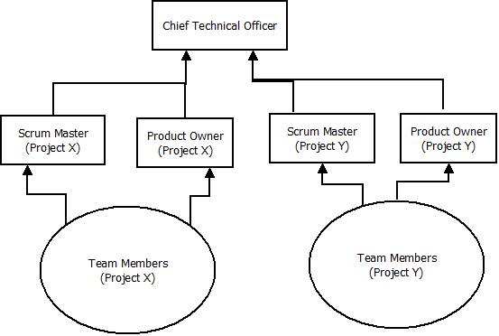

Figure 5.2 - Team Structure in BLUEsat



### Team Members

Teams in BLUEsat usually consist of four or five members. Teams are formed with a balance of experienced members and newer members of the society. The experienced members in the team work in development and do their best to share knowledge and skills with the other members of their team.

### Scrum Masters

Senior members of BLUEsat who have been identified as having a good grasp of team-working principles are selected as Scrum Masters. For a particular team, Scrum Masters have the dual role of buffering teams from distractions from development and guiding the work done by the team.

The chief responsibility of the Scrum master is to ensure that the team is operating in a coherent and effective manner. This means ensuring that the team has enough resources to perform their allotted tasks, resolving team conflicts and identifying performance issues within the team. Additionally the Scrum master will be the main implementer of team improvement strategies brought up at Scrum Master and other general meetings.

The Scrum Master also has the responsibility of maintaining credible project progress documentation. This documentation must be maintained such that members of other teams or other senior members can easily check on the progress of another’s project.

### Product Owners

Product owners are selected as members with the most developed knowledge of the requirements of certain teams. The chief responsibility of the Product Owner for a project is to maintain the technical direction of the project. This means ensuring that systems are being designed to meet the specifications and requirements of the BLUEsat project as a whole.

Product owners are expected not to only have a strong belief of the requirements of their particular project, but also have a good knowledge of the BLUEsat project as a whole.

Product owners will declare tasks as being ‘complete’ and decide whether or not goals have been adequately met. In the case where the team is lacking in technical direction, it is the Product Owners duty to maintain the team members belief in the direction and vision of the project.

### Chief Technical Officer

The Chief Technical Officer’s main responsibility is maintaining the project management and technical direction of the BLUEsat project as a whole.

In BLUEsat the Scrum Masters and Product Owners are managed by the Chief Technical Officer. The Chief Technical Officer has the responsibility of selection of the scrum masters and product owners. Furthermore, the Chief Technical Officer (CTO) is responsible for oversight of all teams in the capacity of both Scrum Master and Product Owner. In this way the CTO is the “Scrum Master of Scrum Masters” and “Product Owner of Product Owners”.

## Sprint Reviews

In order to maintain visibility within the project, each project has a formal meeting at the end of every sprint, called a ‘Sprint Review’. The purpose of the ‘Sprint Review’ is to consolidate progress made in the previous sprint, check designs by the relevant senior BLUEsat member (see 5.1.3 Product Owners) and plan for the remaining sprints.

In these meetings, progress is noted and the central Project database updated. These meetings also record action point for any issues that the team may raise (for example, lack of resources or team conflict).

Every month, all Scrum Masters and Product owners meet with the Chief Technical Officer to discuss important issues raised in Sprint Reviews across the board and to exchange notes on team morale and project progress.

# Satellite Technical Overview

BLUEsat’s intended purpose is to service the Amateur Radio community whilst being a vehicle for experimental payloads. That is, the satellite is to assist in communications between members of the Amateur Radio Community worldwide, whilst also allowing simple payloads to conduct experiments in space.

To that end, the satellite is physically designed much like other Amateur Radio Microsatellites - with much inspiration taken from ECHOsat (AO-51). The satellite is composed of trays in which will contain communications peripherals and the processing units which are responsible for the (relatively) autonomous operation of the satellite.

## Specifications

In order to function as a useful Amateur Radio Satellite, the satellite needs to be able to do the following (listed in increasing complexity but decreasing criticality)

1. Function as an Analogue Repeater
2. Function as a Digital Repeater
3. Be able to store and forward Data (PACsat)
4. Be able to control and process feedback from third party payload units via a generic serial interface

On top of this, the satellite needs to survive autonomously in Low-Earth Orbit (at an altitude of approximately 750km). This means that that along with the above functionality, the satellite must

1. Be able to power itself
2. Survive in a Vacuum
3. Survive the Radiation in a Space Environment
4. Be able to evaluate its own state

## System Design

The satellite itself is split into two main systems, each with its own central processing unit - the Payload Systems and the Critical Systems. Figure 6.1 illustrates the basic system overview and interconnectivity between systems within the satellite.

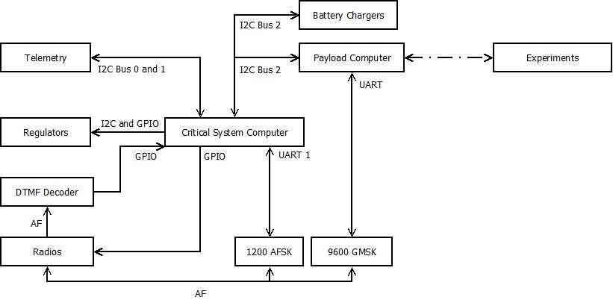

Figure 6.1 – Satellite Systems Overview

The Critical Systems deal with the basic functioning and survival of the satellite, as well as performing basic Analogue repeating. Critical Systems is responsible for powering the different electrical systems, monitoring the health of the satellite and maintaining basic communications with Earth. To that end, the Critical Systems is composed of

* The Critical Systems Computer (CSC)
* Telemetry System
* Communications System
  + Radio Transmitter and Receiver
  + 1200 baud AFSK Modems
* Power Distribution System
* Solar Array and Battery Charging System,

The Payload system consists of the Payload Computer and the experimental Payloads themselves. The Payload computer is to act as an interface between the Satellite’s Payloads and the Critical systems. The Payload computer also provides a separate modem (the 9600 baud GMSK modem) to allow for higher speed communications with the Groundstation.

The Payload system was made distinct from the Critical Systems to allow for greater modularity in the overall design of the satellite. To this end, integration of payloads will not greatly affect the design of the critical systems of the satellite.

A full list of satellite subsystems and peripherals is given below in Table 6.1

Table 6.1 - List of Satellite Subsystems

|  |  |
| --- | --- |
| Critical Systems Computer | Core satellite processor; maintains its health and interfacing with the payload |
| Solar Array | Galium Arsenide Solar Cells |
| Battery Packs | 13.2V NiMh Batteries |
| Battery Charge Regulator | Regulates the solar panel input to the batteries and supplies the satelite with its supply voltage |
| Switchable voltage Regulators | Regulates power for all the satelite's subsystems. The power to the transmitters can be varied digitally |
| DTMF Decoders | Decodes basic commands from earth, using a proven modulation technique |
| AFSK Modems | Provides two way 1200bps communication with earth |
| Beacon | Transmits BLUEsats callsign in audio morse code format on demand |
| Switching Circuit | Interfaces all the communication devices with the redundant transmitters and receivers |
| Telemetry | System of 80 sensors and the communication path to the critical systems computer |
| Radio Transmitters | Hamtronics TA541. Space proven |
| Radio Receivers | Hamtronics R100. Space proven |
| Payload Computer | Computer Responsible for handling processing of payload data |

## Mechanical Structure

*Relevant Drawings:*

|  |  |
| --- | --- |
| *MECH0008* | *Tray 0: Baseplate* |
| *MECH0009* | *Tray 1: Transmitters* |
| *MECH0010* | *Tray 2: Flight Computer* |
| *MECH0011* | *Tray 3: Batteries* |
| *MECH0012* | *Tray 4: Power Control* |
| *MECH0013* | *Tray 5: Receivers* |
| *MECH0014* | *Transmitter Housing* |
| *MECH0015* | *Receiver Housing* |
| *GENN0002* | *Tray 2 PCB Dimensions* |
| *MECH0015* | *Receiver Housing* |
| *MECH0016* | *Solar Backing +X Face* |
| *MECH0017* | *Solar Backing +Y, -Y and -X Faces* |
| *MECH0018* | *Solar Backing +Z Face* |
| *GENN0001* | *Tray Interconnects (spread sheet)* |
| *GENN0003* | *Tray Interconnect Diagram* |

The Satellite’s Mechanical design is based off of other similarly sized Amateur Radio Microsatellites, with particular inspiration taken from ECHOsat (AO-51). The satellite is composed of five square trays stacked vertically to create a 250x250x250mm cube with a Solar Panel on each of the 6 sides.

The trays will contain the electronic circuitry of the satellite. There are connectors attached to the backplane of the satellite in order to allow for connections between trays. The trays (from top to bottom) are assigned electronics as follows (referencing Figure 6.2)

* Tray 5 - Radio Receiver and Hybrid Coupler
* Tray 4 - Payload Computer and Payload Systems
* Tray 3 - Batteries
* Tray 2 - Critical Systems and Power Systems
* Tray 1 - Radio Transmitter and Hybrid Coupler

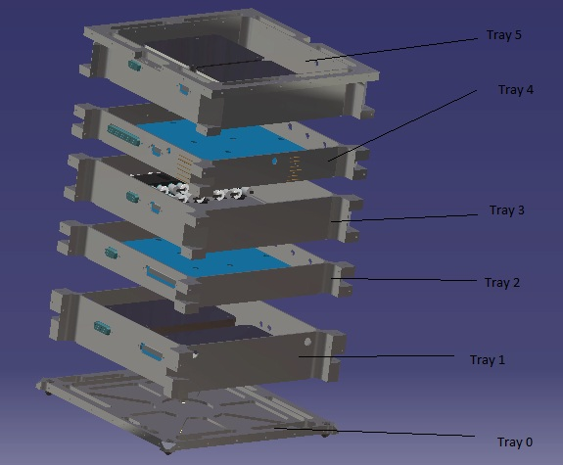

Figure 6.2 - Exploded view of the satellite tray system

Trays 5 and 1 have specialised mounting holes and covers in order to attach and shield the Radio units. Trays 4 and 2 are designed to maximise the amount of surface area available for printed circuit boards. Tray 3 is designed to allow for mounting of two battery packs that is to make up the battery array.

Drawing GENN0002 shows the dimensional restrictions of the Tray 2 and Tray 4 Printed Circuit Boards.

Once assembled, the trays allow for attachment of flat panels on each side, onto which the Solar Arrays will be mounted. The top and bottom panels will have allowance for Antennae footholds.



### Wiring Harness

The connections between trays will be managed by point to point connection between D-Subminiature connectors mounted on each tray. The ‘wiring harness’ will consist of each of the individual wires soldered to the relevant point on each connecter. The tables and diagrams of tray interconnections can be found in GENN0001 and GEN0003 respectively.

### Current Progress

All components of the structure, save the wiring harness and the antennae footholds have been designed. Each individual tray has been manufactured and currently sits assembled in the BLUEsat clean-room. Errors in manufacture mean that the solar backing panels do not currently assemble with the base satellite assembly.

The base structure (all Trays assembled, minus the solar panels) has been put through preliminary vibrational testing. Testing will need to be re-carried out once all PCBs and solar panels have been manufactured and assembled.

The wiring harness has been specified according to drawing GENN0001 and GENN0003.

### Future Plans

The solar backing plates need to be re-manufactured and assembled.

The wiring harness is pending design and construction, though all interconnects have already been finalised and documented.

The antennae footholds are in the process of being designed and will need to be assembled into the main structure.

Vibrational testing will be carried out again once all peripheral structures have been manufactured and assembled.

## Communications

*Relevant Drawings:*

|  |  |
| --- | --- |
| *COMS0001* | *Beacon* |
| *COMS0002* | *AFSK Modem* |
| *COMS0003* | *DTMF Receiver* |
| *COMS0004* | *Switching Circuit* |
| *COMS0005* | *Comms Test Board* |
| *COMS0006* | *Switching Circuit Signal Flow* |

BLUEsat will communicate with Earth via VHF radio transmitters and UHF radio receivers. Digital data from the Critical Systems Computer and Payload Computer will be modulated by AFSK (Audio Frequency Shift Keying) and GMSK (Gaussian-Minimum Shift-Keying) modems, respectively, for transmission or reception by the radios. The communications system also includes an audio Beacon that will continuously loop between data transmissions.

The function of each communication device in the satellite (shown on Figure 6.3) is as follows:

* **Transmitter radios (TX1 and TX2) (see TA451 datasheet) -** For the satellite to communicate with radio users on the ground, it uses a pair of Hamtronics TA451 transmitter radios. These accept an audio frequency input and produce an approximately 425 MHz FM modulated signal at the output, which is sent on to the transmitting antenna.
* **Receiver radios (RX1 and RX 2) (see R100 Datasheet) -** Conversely, for radio users to send data or audio to the satellite there is a pair of Hamtronics R100 receiver radios. These radios operate at around 150 MHz and use FM modulation.
* **GMSK Modems (Drawing PAYL0001) –** BLUEsat uses a pair of 9600 baud Gaussian Minimum Shift Keying (GMSK) Modems. These modems exchange digital data with the Payload Computer and used primarily for high-speed, non-critical communications such as PACSAT (Packet Satellite) and payload (e.g. EDAC, Namuru) communications.
* **AFSK Modems (Drawing COMS0002)** - BLUEsat also uses 2 Audio Frequency Shift Keying (AFSK) Modems. These modems are relatively slow (1200bps) but more accurate than 9600bps GMSK modems. For this reason, they are used for mission-critical transmissions such as telemetry data transfer and computer software updates. The AFSK modems connect directly to the CSC via UART channels to facilitate data transfer.
* **DTMF (COMS0003) -** The DTMF receiver is used to communicate root level commands to the Critical Systems Computer. The DTMF circuit accepts this command as audio from the receiver decodes the audio into a digital value and passes it on to the CSC.
* **Beacon (COMS0001)** - The Beacon is a simple, robust digital circuit that generates a fixed audio Morse code message. It continuously transmits the Morse code message “VK2UNS BLUESAT” at a speed of 12 wpm (PARIS standard) using a 1kHz square wave as the tone.

Each of the above communication devices are duplicated for sake of redundancy. In order to manage communication lines and communication times, the critical systems compute controls a central switching circuit which routes communication lines based upon current priority. The communications array is connected according to Figure 6.3

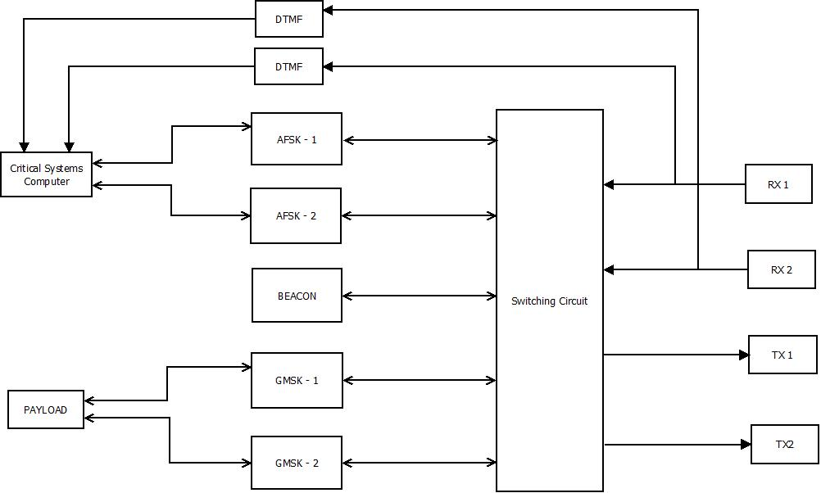

Figure 6.3 - Communications Layout

### Switching Circuit (COMS004)

Because of the usage of three different communication schemes by the satellite and redundant devices implementing these schemes, there must be a device that allocates access to the limited number of transmitting and receiving radios. To this end, a switching circuit is included, controlled by General Purpose Input-Output pins from the CSC.

Each redundant pair of radios is connected to a 2-to-1 analogue multiplexer. The signal from each of these multiplexers is connected to another multiplexer that either connects to the modems or connects the TX radio input to the RX radio output (repeater mode).

The signal from the receivers is branched off to two 2-to-1 multiplexers, one for AFSK, one for GMSK receive channels. This way, both types of modems can receive data independently (because each is serviced by a different computer).

The DTMF receiver does not require switching - the receiver multiplexer output is connected directly to the DTMF RX line. This, in effect, allows the DTMF signal to complete sidestep the switching circuit, ensuring unfettered root access to the satellite.

The transmitting devices are serviced in a similar way, the difference being that in addition to the modems, the beacon must be accommodated. For this reason, instead of two 2-to-1 multiplexers, we use an 8-to-1 multiplexer.

Finally, BLUEsat must also need to retain the ability to implement analogue repeating mode, where the output of the Radio Receivers is to be instantly retransmitted by the Radio Transmitters, needing a 2-to-1 multiplexer.

Tallying all the multiplexer usage, there are

* 2 x 2-to-1 (radios)
* 2 x 2-to-1 (repeater)
* 2 x 2-to-1 (modem receive side), and
* 1 x 8-to-1 (modem transmit side + beacon)

For a total of six 2-to-1 multiplexers and one 8-to-1 multiplexer

A diagram of the designed multiplexer array is shown below in Figure 6.4.

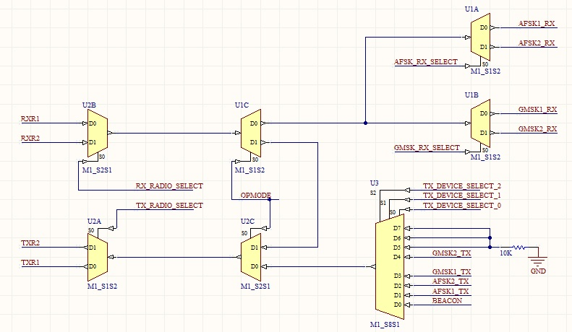

Figure 6.4 - Switching Circuit Signal Flow

The analogue multiplexers chosen for the new switching circuit are taken from the 4000 CMOS series. Taking into account the requirements stated above, the switching circuit requires two 4053s and one 4051. Unused channels are tied to ground with 10k resistors. Each chip is decoupled to minimize EMI effects. The select pins of the multiplexers are connected to a pre-allocated row of GPIO pins on the CSC.

The detailed schematic is shown in drawing COMS0004.

### Current Progress

All of the digital (non-radio) devices have been prototyped and proofed. The entire communications array has been assembled and tested, minus functioning radio receivers. To date we are able to demonstrate manual switching and transmission of each data type. The current testing rig is also able to receive raw audio input (as if having been decoded by the Radio Receivers) and interpret data intelligently.

### Future Work

Whilst radio receivers have been sourced and constructed, they have proven to be problematic in fine tuning and testing for BLUEsat’s particular purposes. To that end, the Radio Receivers need to be debugged and possibly modified in order to allow for integration into the rest of the communication subsystem.

GMSK drivers have also yet to be formalised. The method of data transmission via GMSK has proven to be significantly more complicated than transmission via AFSK modems. Whilst we are able to push simple streams of data, we have not yet formalised the modem drivers to be able to send more sophisticated packets.

Finally, a communications stack protocol (namely the AX.25 Stack Protocol) needs to be ported for use in the Critical Systems Computer in order to allow for universal communication with any Groundstation array. The current communications array currently utilises a very primitive data packeting system.

## Critical Systems Computer

*Relevant Drawings:*

|  |  |
| --- | --- |
| *CRSC0001* | *Critical System Computer - Top Level* |
| *CRSC0002* | *Critical System Computer - Microcontroller* |
| *CRSC0003* | *Critical System Computer - Memory* |
| *CRSC0004* | *Critical System Computer - Serial* |
| *CRSC0005* | *Critical System Computer - Power* |

The critical systems on the satellite (being the Communications, Telemetry and Power systems) will be controlled via a central micro-controller and memory system complete with a multi-threaded Operating System. This central controller is called the Critical Systems Computer. This system is to be distinct from the Payload Computer, whose responsibilities lie solely in interfacing with BLUEsat’s payloads.

The Critical Systems Computer will directly perform the following tasks

* Power Systems
  + Voltage Regulator Control
  + Battery Charge Regulator Control
* Telemetry data request and storage
* Communication
  + RX and TX Radio control
    - Power regulation
    - Line switching
  + AFSK (low speed) data transmission

The critical systems computer will run according to commands received from earth via transmission of nine digit codes transmitted in Dual Tone Multi Frequency (DTMF) format.

### LPC2468 Microcontroller

The microcontroller central to the design of the Critical Systems Computer is the ARM7 LPC2468 manufactured by NXP Semiconductors. Relevant circuit designs can be found in the CRSC family of drawings. The microcontroller was chosen for

* UNSW Undergraduate familiarity with the ARM7 family of microprocessors
  + Providing undergraduate engineers with an accessible and easy environment in which to develop
* The External Memory Controller
  + Simplifying interfacing with the CSC and the external memory needed to store telemetry and state data.
* The number of communication lines available
  + Three I2C enabled ports and Three UART ports
  + I2C is used on the satellite for communication with all of the Telemetry, Payload and power systems, whilst UART is used for both the 1200baud modems and for terminal debugging.
* The number of input/output ports available.
  + Required for switching of power regulation for each electrical subsystem in the satellite.

Currently, all hardware and software prototyping has occurred on a LPC2119 development board. This board (dubbed the “JTAG Board”) contains an LPC2119 ARM7 microcontroller. This board is both much cheaper and less feature heavy than the LPC2468 board, but contains the same architecture processor and contains a similar (if more lightweight) feature set. For these reasons, the LPC2119 is the ideal development tool for prototyping of all the satellite’s peripherals.

### FreeRTOS

On this microcontroller, BLUEsat will run a distribution of FreeRTOS (Free Real-Time Operating System), modified for the specific operational needs of the satellite.

This Operating System was chosen as it was open source project, provided a stable scheduler in a small footprint and has an active NXP ARM support.

The CSC OS is organized in the following fashion (Figure 6.5: CSC OS Structure)

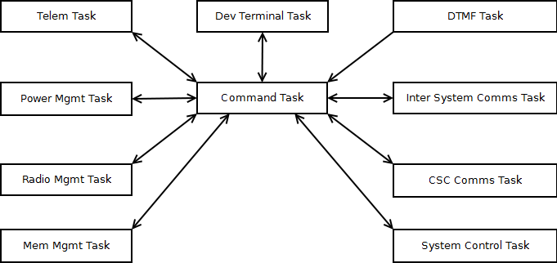

Figure 6.5: CSC OS Structure

Within the operating system, drivers and applications are intended to be run in order to control the critical systems of the satellite according to pre-defined constraints. Each task illustrated in Figure 6.5: CSC OS Structure calls applications relevant to the responsibilities defined below in Table 6.2: CSC Task responsibilities

Table 6.2: CSC Task responsibilities

|  |  |
| --- | --- |
| Task Name | Description |
| **Command Task** | High Priority message switching task to allow inter process communication. |
| **System Control Task** | Manage operation modes and effect commands from the Ground Station. |
| **Telemetry Task** | Gathers telemetry data, archives old data and packages up responses to be sent to the Ground Station. |
| **Power Management Task** | Manage system power usage based on operation modes and available power by turning on and off subsystems via the regulators. |
| **Radio Management Task** | Controls which devices have access to the radios. |
| **Memory Management Task** | Provide persistent storage of data for all processes. |
| **CSC Communications Task** | Performs encoding and decoding of data used during communications with the Ground Station. |
| **Inter System Communications Task** | Allows communications and data transfer with the payload computer. |
| **DTMF Task** | Receives and decodes command codes from the Ground Station. |
| **Development Terminal Task** | Developer interface used during development to debug processes. |

The central command task operates based on feedback from the System Control Task on what operating mode the satellite is required to be in. These operating modes are specified via two sources:

* Event triggers (such as hardware failure or low battery charge with no sunlight)
* DTMF Commands (nine digit codes to be transmitted from a Groundstation)

For more on the way in which DTMF is interpreted, see 0 DTMF

### Current Progress

All software drivers and applications compile and run as expected on the JTAG (LPC2119) boards. Each task has been written (with some clean up necessary) and tested to work individually, independent of the System Control Task.

The LPC2468 controller board has been designed, constructed and proofed. This board currently contains a USB interface to allow for quick programming. The board also currently has the capability to ‘hot swap’ three different kinds of memory modules. This allows for testing of the effectiveness of using different memory types for the purposes of implementing them on the satellite.

For all current drawings of the LPC2468, please consult the CRSC family of drawings.

### Future Work

All operating modes and DTMF commands need to be finalised and implemented. Currently, only examples of both functions exist. The focus so far has been on driver and low level application implementation. As such, currently all applications are run one at request of a user to facilitate module debugging. The Scheduler will need to be integrated System Control task to allow for the satellite to operate via specified operating modes.

Furthermore, the operating system and all applications and drivers need to be ported from the LPC2119 board to run on the LPC2468 board. Some settings and configurations need to be changed in order for drivers and applications to have the same functionality as on the JTAG boards. The code repository is also being refactored during this process to allow for a more formal and modular system.

The different memory types currently in tender also need to be tested and evaluated so that a final memory type can be chosen to be included on the final design.

Finally, the PCB for the LPC2468 CSC board needs to be finalised, with the USB interface removed and implementing the chosen memory type. This PCB needs to be designed such that it integrates with the other critical systems, sitting in Tray 2.

## Power Overview

The BLUEsat Power system is divided into three sub-systems, the Solar Array, the Battery Charge Regulator and Voltage Regulators.

The array will feed power into the Battery Charge Regulator which regulates power into the battery array. Power from this battery array then gets passed to the Voltage regulators, which distribute power to the different subsystems of the satellite. Figure 6.6 illustrates the flow of power from solar panels to each electrical subsystem in the satellite

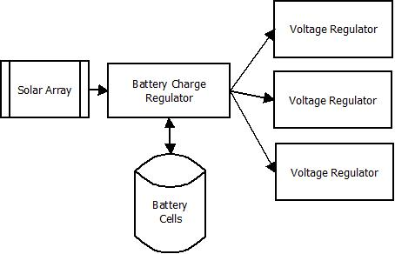

Figure 6.6 - Simplified overview of the Satellite Power System

The power system has been designed such that the Critical Systems computer is able to monitor and modify the state of the charging circuit, as well as being able to shut off power to different parts of the satellite.

## Solar Array

The current design for Solar Array consists of six solar panels. Each panel will sit 14 Gallium Arsenide solar cells connected in series. These six panels will sit on each of the six sides of the satellite, as illustrated in Figure 6.7.

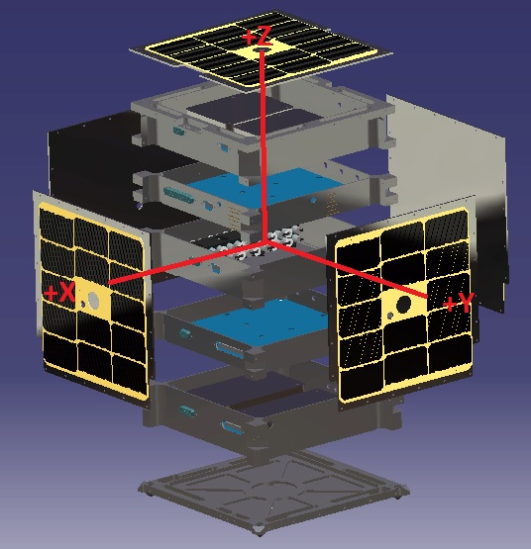

Figure 6.7 - Exploded view of Satellite structure including solar Array

### 

### Current Progress

BLUEsat currently has about 200 electrically functioning gallium arsenide solar cells and about 48 electrically non-functioning cells which are intended for use in mechanical testing. These cells are from Spectrolabs and are specifically designed for space, many being already used in space applications. These cells already have an inbuilt bypass diode and an anti-reflection coating for diffuse light.

These cells were purchased in 2004 and thus have undergone some degradation due to exposure to moisture and other factors. These cells have been kept in a clean room with desiccant in order to reduce the degradation due to moisture, some cells from the batch were tested recently and their efficiencies are relatively close to their data sheet efficiency of 21%. Theoretically we can still use these cells on the satellite if necessary providing that there enough cells in good operating condition

### Future Work

BLUEsat will need to obtain new cells from either via purchasing them outright or getting surplus from another project. The first method will require a large amount of capital so getting surplus cells would be preferable. Despite the fact it will help improve the performance of our satellite if surplus cell can’t be obtained and purchasing regular cells is too expensive the project will make do with the older cells.

If possible BLUEsat will obtain cells which already have their own cover glass in order to boost the overall efficiency and lifetime of the system. Before putting together the cells for the satellite’s solar panels members will have to undertake a course which teaches space grade soldering which will help ensure the panels last for the lifetime of the satellite.

## Battery Charge Regulator

*Relevant Drawings:*

|  |  |
| --- | --- |
| *POWR0001* | *BLUEsat Peak Power Tracker* |

BLUEsat will have four strings of eleven Nickel Metal Hydride (NiMh) battery cells, totalling a specified supply voltage of 13.2V. The proposed construction of the battery pack is shown below in Figure 6.8.

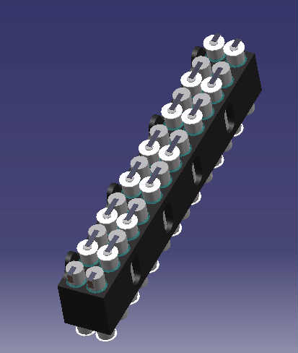

Figure 6.8 - Battery Pack Assembly

Each battery string has a Battery Charge Regulator (BCR) sitting between it and the Solar Array Bus. The BCR serves two purposes: charging the battery, and ensuring maximum power is gained from the solar array.

The circuit itself is currently based upon the LT3652 Battery Charging Chip. Power to each BCR enters from the solar array bus, and is sent to the LT3652. This chip controls the peak power tracking, and battery charging, functionalities of the circuit. The circuit design can be found in drawing POWR0001.

The LT3652 measures the current entering from the solar input over a 12 hour cycle, and adjusts a digital potentiometer such that the voltage across the solar input leads to maximum power into the battery.

Sensors also feed input into the LT3652, giving information about the battery temperature and power consumption. If the battery statistics are not within the required ranges, battery charging is stopped.

### Current Progress

The Battery Charge Regulator was implemented onto a prototype printed circuit board as part of William Du’s thesis on Peak Power Point Tracking (2011). However, when this circuit was recreated, it was found that batteries did not charge to full charge. This testing ended up damaging the current sample cells used in the project.

### Future Work

Currently the team is performing further testing on the performance of the PPT board and making modifications as necessary so that the BCR will perform to the standard required on the satellite.

In particular, the mechanism used to determine full charge on the batteries will need to be tested in greater detail. Once these issues are fixed, then the designs for the BCR can be finalised and integrated into the rest of the power system within the satellite.

## Voltage Regulation

*Relevant Drawings*

|  |  |
| --- | --- |
| *POWR0002* | *Tray 2 High Level Power Layout* |
| *POWR0003* | *Tray 3 High level Power Layout* |

The various systems of the BLUEsat have many different power requirements. The purpose of the Voltage Regulator is supply each system with its required current and voltage, as well as to provide the Critical Systems Compute with the means to shut off different systems in the satellite in the event of failure. In total there a 13 points where power needs to be able to be switched off, with 3 different operating voltages across the satellite. The voltage levels required for each switchable device is shown in Table 6.3.

Table 6.3- Devices and voltage levels required

|  |  |
| --- | --- |
| **Device** | **Voltage Level** |
| AFSK1 | 3.3v |
| AFSK2 | 3.3v |
| DTMF1 | 3.3v |
| DTMF2 | 3.3v |
| Beacon | 3.3v |
| CSC | 3.3v |
| Payload Computer | 3.3v |
| Switching Circuit | 3.3v |
| Telemetry | 5v |
| TX1 | 13.2v |
| TX2 | 13.2v |
| RX1[1] | 13.2v |
| RX2 | 13.2v |

The voltage regulators will be connected to a central power supply rail running at 13.2v (the rated voltage of the batteries). From this supply rail, the voltage will be stepped down for each subsystem according to Table 6.3.

Switching will be achieved via digital input to each regulator. The switching inputs to each regulator will be controlled by the Critical Systems Computer controlling an I2C port expander, as illustrated in drawing POWR0002 and POWR0002. This design is up for tender, however, as it is noted that the I2C line represents a single point of failure for several devices. Despite the proven robustness of I2C serial communication, using General Purpose Input Output (GPIO) connections to the LPC2468 is currently being considered.

Radio Receiver 1 (RX1) will be the only device connected directly to the main power rail, whilst each other device will be connected to a switchable regulator. The system has been designed this way to allow for the satellite to be constantly ‘listening’ for a signal from Earth, in that at least one Radio Receiver will always be switched on.

### Current Progress

A previous design has been proofed, utilising one voltage regulator (based on the LM2676 voltage regulator) for each subsystem that required switching. Spatial concerns, however, have proven this design to be infeasible as we could not fit 13 of these within any tray, and still have space for other peripherals.

A new design has been put forward using one regulator for each voltage and then separate switches for each device, as opposed to having one regulator for each device. Based on this concept, a basic system overlay has been designed with considerations for PCB design and failure points. The system has been specified and expected behaviour formalised.

### Future Plans

Chip selection and prototyping needs to occur for the new power distribution system. Drivers also need to be written in order to implement the I2C switching system.

Once the design has been proofed, a final PCB will be made implementing the full power distribution array for the entire satellite.

## Telemetry

*Relevant Drawings*

|  |  |
| --- | --- |
| *TELM0001* | *Telemetry - Top Level* |
| *TELM0002* | *MAX127 Telemetry Circuit* |
| *TELM0003* | *Temperature Sensor Circuit* |
| *TELM0004* | *Telemetry Current Sense* |

The satellite’s telemetry systems are designed to sense temperature and voltage at different points on the satellite. To this end the current telemetry system design allows for a network of up to 160 temperature and voltage sensors to feed data back to the critical systems computer. This data is then transmitted to Earth for analysis and action by Groundstation Operators.

The design of the Telemetry system is based around the MAX127 - an 8 channel Analogue to Digital converter. Each channel of the MAX127 is connected to either a voltage sampling point on the satellite or an amplified signal from a temperature sensor. Up to ten MAX127s can communicate on a single I2C serial line to the Critical systems computer. The system layout is illustrated in Figure 6.9.

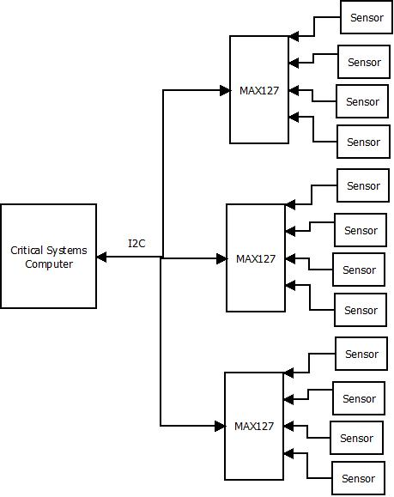

Figure 6.9 - Telemetry System Overview

### Temperature Sensors

The satellite utilises AD590 temperature sensors connected to a Current-Sense Amplifier. The AD590 outputs the current temperature in micro-amps, independent of voltage source. This current is amplified such that the MAX127 is able to take an accurate reading for analysis by the Critical Systems Computer.

The sensor allocation is given below in Table 6.4.

Table 6.4 - Telemetry Sensor Allocation

|  |  |  |
| --- | --- | --- |
| **Tray** | **Sensor Number** | **Usage** |
| Tray 5 – Receiver | 1 - 8 | General component/tray status |
| Tray 4– Payload | 9 - 10 | General component/tray status |
| Tray 2 – CSC and Power | 25-40 | CSC and Power tray health |
| Tray 3 – Battery | 41-80 | Battery temperature and output health |
| Tray 1 – Transmitter | 49 - 52 | Tray and hull temperature |
| 53-57 | Key PCB health |
| Solar Cells | 58 - 80 | Solar panel temperature |

For further detail on the Telemetry system and component circuitry, consult the TELM family of drawings.

### Current Progress

To date, the telemetry circuitry has been prototyped and proofed with accompanying software drivers. The current telemetry system is able to continuously poll and display the temperature of multiple sensors. All circuitry current sits on prototype Printed Circuit Boards with circuit schematics finalised according to the TELM family of drawings.

### Future Work

From current designs, the PCBs that will sit on the final satellite need to be designed. Telemetry ‘nodes’ will need to be placed in each of the five trays of the satellite. Within each tray, each sensor will then have a local MAX127 ADC to communicate with. From the separate trays, PCBs will need to be designed such that the I2C communication lines from each MAX127 connect to the Critical Systems Computer on Tray 2.

Furthermore, the Telemetry software will need to be implemented such that it retains a history of data. Currently the Telemetry application is able to display information from the last poll, but is lacking functionality in being able to store previous telemetry information into the computer memory. The telemetry application will need to be extended so that it includes an effective memory storage system that will minimise the amount of space that a particular set of data will take.

## Payload Computer

*Relevant Drawings*

|  |  |
| --- | --- |
| *PAYL0002* | *Payload Computer - JTAG Interface* |
| *PAYL0003* | *Payload Computer - Memor Interface and Ics* |
| *PAYL0004* | *Payload Computer - Micontroller I/O interface* |
| *PAYL0005* | *Payload Computer - Microcontroller Power* |
| *PAYL0006* | *Payload Computer - Overview* |

The purpose of the Payload Computer is to serve as a base for all novel functionality which might be implemented using the BlueSat system. At present, the system consists of an ARM microcontroller which will run a Linux based system. The low level software redundancy of the system is provided via the boot loader which is conceived to manage and maintain kernel and application system images. This system was designed and coded by Matt Brindley and more detailed design document is available refer to his thesis.

### Payload Microcontroller

The hardware of the Payload System is based around a Philips ARM9 microcontroller. This microcontroller is compatible with the chosen operating system as well as satisfying our other requirements. It a contains sufficient number of GPIO pins to communicate with two Gaussian Minimum Shift Keying (GMSK) modem modules (one primary, one backup) which receive digital communications. It also has two I2 C buses for communication with the Critical Systems Computer (CSC) and the various payload hardware systems. Finally it has internal interfaces providing support for discrete RAM and NAND flash chips which are required to support the operating system and to provide space for experimental data and programs.

### Bootloader

The base Operating System for this Payload computer will be the SeL4 Microkernel (developed at NICTA Labs). This kernel has been extensively tested and is proven to be stable and thus ideal for our sensitive system and should provide the required core system stability. To ensure the kernel and application images have not been damaged in memory, the Payload Computer needs to have the ability to check the integrity of an OS image and load a backup image if errors are found. It also needs to be capable of receiving and loading a new OS image from the BLUEsat Groundstation over the AX.25 protocol using GMSK modulation over the satellite’s radio system.

This is job of the boot loader is yet to be completed but will be built on top of the open source boot loader, Das U-Boot . The protocols and drivers that the boot loader will need to support include the BLUEsat radio switching protocol, I2 C for the CSC to communicate throughout the boot and recovery processes, AX.25 for the transfer of OS images and drivers for the GMSK modem modules. Once it has these capabilities, the U-Boot Download Mode will need to be further modified to handle automatic image checking and management.

### Communication

Finally for the PS to be functional, a standardised method for communicating with all third party experiments and devices must to be implemented. Because this depends entirely on what sort of third party functions are taking place through BLUEsat, this protocol has yet to be fully determined.

### Current Progress

To date, a Payload board has been prototyped and sections proven to work. Due to complications with soldering the main Microcontroller, however, we have as yet been unable to prove that the central microcontroller is operable on the implementation designed in the PAYL drawings.

A basic bootloader and kernel has been implemented on a development ‘Beagle Board’. This bootloader and kernel is capable of simple serial communication and image integrity checking.

### Future work

The Payload prototype board will need to be re-soldered in order to test the implementation of the central microcontroller.

Once this board has been successfully constructed and tested, the current implementation of the payload bootloader and operating system will need to be ported over to the new board, ready for application development and insertion for third party payloads.

# Conclusion

The implementation of new documentation and project management infrastructure has successfully ensured the professional integrity of a volunteer progress. The implementation of the modified SCRUM project management system has allowed for a successful consolidation of all past work, upon which the current generation is very rapidly building.

The current state of the project also facilitates the nature of ‘inheritance’ that comes with a long term and chiefly undergraduate project. The conclusion of this document will represent another step towards increasing project productivity and integrity, as knowledge becomes more easily handed down to new members. The documentation in place and being developed ensures that knowledge is never lost and that productivity can be maintained by the enthusiasm of the members, unhampered by difficulties brought upon by poor infrastructure.

## Technical Progress Summary

As of October, 2011, all communication systems have been proofed and tested. Furthermore, the Critical Systems Computer is successfully communicating with and handling all Critical Subsystems. The Mechanical structure of the satellite has been proofed and awaits further qualification testing (with the final assemblies).

The overall design of the satellite and specification of all other subsystems (being Power and Payload) have been finalised and are awaiting prototype construction and testing. The Solar, Battery Charging and Power Distribution Systems have all been designed and are awaiting prototyping and testing.

The main aim of the road ahead is to physically integrate all developed systems into ‘launch’ form. The prototypes that currently exist will need to be physically implemented in their final forms (i.e. the components that will sit on the satellite proper). The final Operating system for both the Payload Computer and the Critical Systems Computer will also need to be finalised and compiled into their final form.

With the completion of these two major integration tasks and the final design of the power systems, the Satellite will reach a state where it is ready for Qualification testing and Launch.

1. RX1 Will always be connected to the power rail, without a regulator.